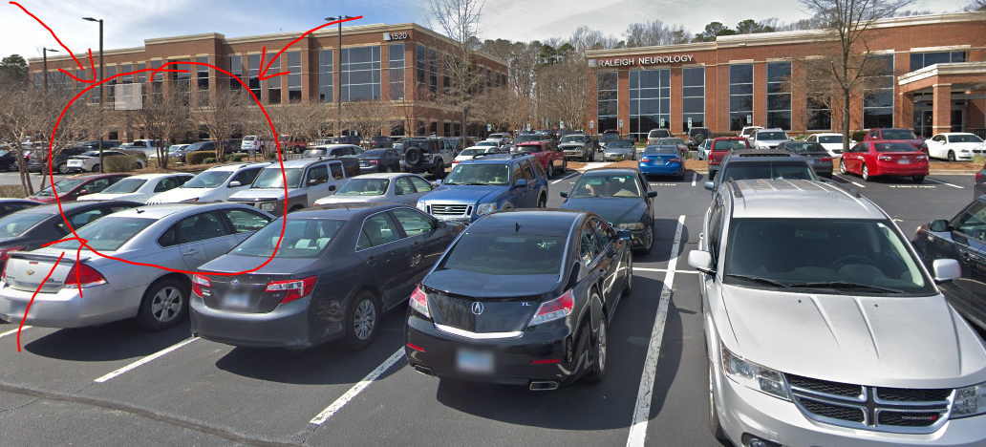
This is the building (circled in red), not the one that says “Raleigh Neurology”.

How to get to RNA, the secret way of maltenbu
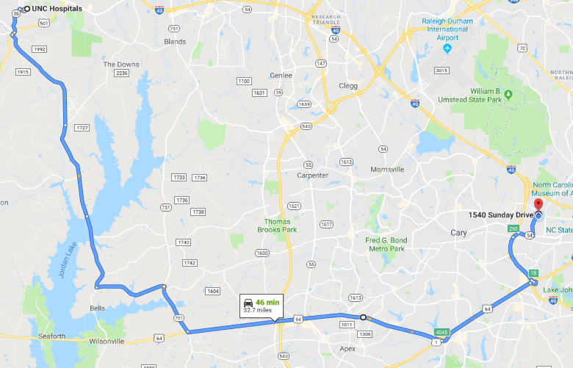
This magical forest and swamp path will take you a longer distance and will consistently take more time than I40, but has less traffic, and can almost always be done in about an hour, whereas leaving UNC at 5PM and trying to take I-40 will take up to 90minutes.
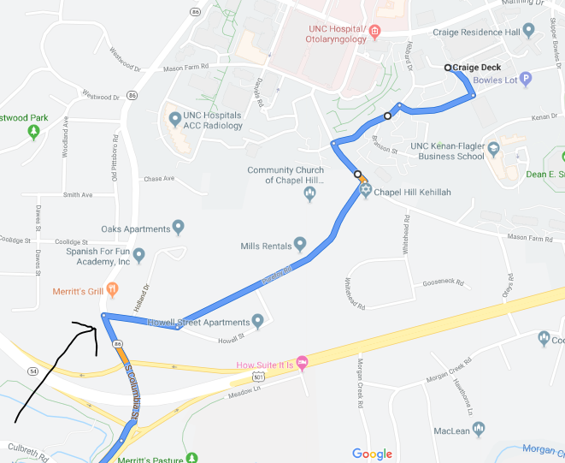
I recommend this additional round-about way of getting out of campus. If you leave close to 445 or 5PM it can take 15-20 minutes to get around the parking decks, so this can help bypass that. Leave out the bottom of Craig Deck and take some back roads to Purefoy Rd. It can be tricky turning left onto South Columbia (see arrow). There is a lot of south-bound traffic backed up here so you just have to jump in there and cut people off. In my experience, people seem to realize this is the only way to turn left here and usually are not too upset about it. Otherwise you have to turn right then left up the street to go south again.

